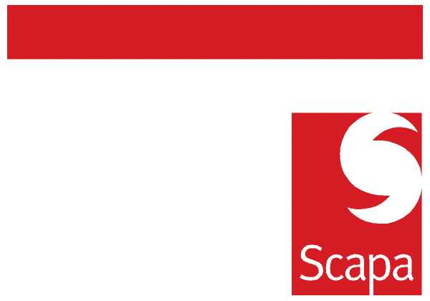

ANNOUNCEMENT

Creation of a new Sales Desk function in Scapa Europe

As part of the Remodel briefing in Oct 2009 we announced that we will start to differentially manage our business by changing the method that we use to manage our existing customer base. As a cornerstone of this change, we are announcing today the introduction of the Sales Desk function within the commercial organisation.

This function already exists in NA and implementation in Europe will be managed by Neil Radcliffe and then transition to local sales management.

Sales Desk is a key factor in the evolution of our commercial activities going forward. There is a need to manage the large number of small customers (or larger transactional customers) within our business in a different way, to allow our external sales team to focus on converting larger and more profitable sales opportunities. Work to identify the profile of customer to be managed by this new function, and subsequently the details of the customers involved, has now been completed.

The intention is that we will initially have a team of four people, to cover English, German, French and Italian speaking customers, and these people will be office -based at the most appropriate site in each case. We will start a pilot in the UK, and this will allow us to refine the sales desk process, and the support mechanisms, ahead of rolling this out in Europe. Concurrently the external/internal recruitment process will start for the other team members.

A further announcement will be made today concerning the pilot and there will be regular updates in the coming weeks as this new function gathers momentum

Barry Andrew
Commercial Director

24.03.2010

